Discussion

Student Name

Institution affiliation

Instructors name

Course

Date

Slope=$\frac{y2-y1}{x2-x1}$
$\frac{68-44}{371-321}$ = $\frac{24}{50}$ = 0.48${cm}^{3}k^{-1}$
1. Purpose of the experiment
To investigate the relation between temperature and volume for a gas.
2.In reality a gas would have turned into a liquid before reaching of temperature of -273⁰c.
3. An increase in a gas whose volume is 0 at 273⁰c is called an ideal gas.
VαT $\frac{V1}{T1}$ = $\frac{V2}{T2}$
V=CT
$\frac{V}{T}$= C
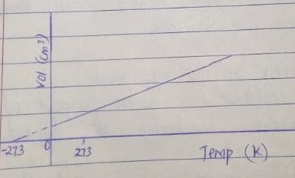
4. In the graph increase in temperature increase the volume of dry air in ml.
When the temperature is at absolute zero the volume is assumed to be zero.
CHARLES LAW
Variables are Temperature and volume
Pressure is kept constant
The Charles law states that the volume of a given mass of gas is directly proportional to the absolute temperature.
VαT $\frac{V}{T}$ = $\frac{CT}{T}$ $\frac{V1}{T1}$ = $\frac{V2}{T2}$
V=CT $\frac{V}{T}$= C
Sketch of graphical representation
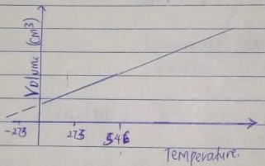
An ideal gas is a gas whose volume is theoretically zero at 273⁰c
Ideal gas law PV=Nrt
Increase is temperature leads to increase in volume and decrease in temperature causes decrease in volume
In boyles law : V α$\frac{1}{P}$
In Charles law V α T
P × V α $\frac{T}{P}$ ×p
PVα T
In Avogrades law V α n
Gas Constant = R
Ideal gas law
PV= nRT
Results from the experiment
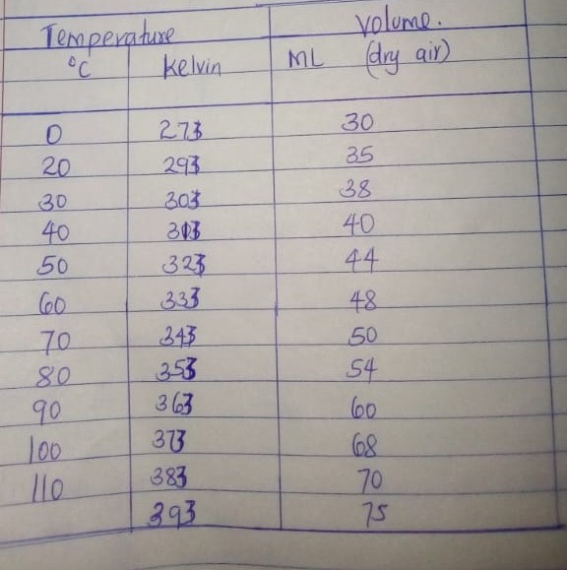

The possibility errors could be the gas can turn to liquid or solid at low temperature below absolute zero.
5.
. 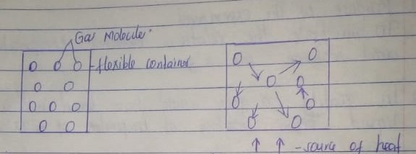

When the heat is introduced to higher temperature gas molecules moves faster, hit the walls of the container more often and with more force. Finally, the container will increase in size.
6. Volume of dry air was calculated since dry air is less dense than humid air therefore gas goes up hence easy to collect
Sources of errors in the experiment
Some air could condense to water vapor at higher apparatus surface, it changes to liquid then solid.
The purpose of the experiment was achieved since the data of temperature and volume was collected and its graph plotted.
Therefore, indicating V α T confirms the Charles Law.

